A model of wireless energy transfer system for a city

Lexiao Lin

*Abstract*—This system is about a model of a city’s illumination powered by a center Tesla Tower to test the application of wireless energy transmission. In this model, you will see a city lighted without wires and an illumination backup system for emergency.

Keywords—Wireless energy transfer, illumination

# Introduction

Since Nikola Tesla pointed out the fact of wireless power transmission, many scientists have tried to make the magical way for power transmission become more practical and can be applied to our city illumination system. However, there are a lot of problems like distance and power source which limit the use of wireless energy transfer. Though it is not practical for long-distant wireless energy transfer system become existed for now, it still remains great potential benefits and advantages if we make it happen in the future.

# design of the system

## The center Tesla Tower

In this model, I will use a center Tesla Tower as the generator for the high frequency alternating electric field which can provide an energy field.

The design of the Tesla Tower can be seen in image 1.

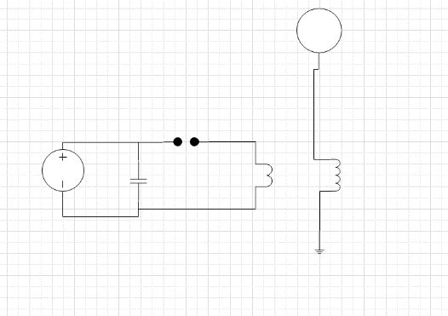image 1

This type is so easy designed and may not quite efficient for the generation of high frequency alternating electric field. But it is qualified to be used in a model.

Firstly, the battery is 9 volts, providing direct current to the transistor so that it will make DC become AC with high frequency.

Secondly, the AC will come into the primary coil which will coupling with the second coil and rise the volt into 900 volts and generate the high frequency alternating electric field.

The volt rising formular is followed:



## The illumination system

I am going to use LEDs (5v) as street lights models. You can see (Image 2) they are all lined in circles and connected with a battery(Backup power source).

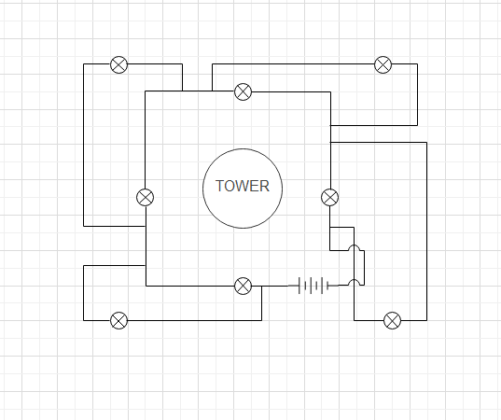image 2

At normal, the LEDs will be lighted wirelessly by the center Tesla Tower. When the wireless transfer system fail to work, the backup system is going to provide power to the illumination system to ensure lights on.

## The backup system for emergency

The backup system is only used for the emergency when the center Tesla Tower is not working.

In this model, I use a battery as the backup power source. You can see the design in image3.

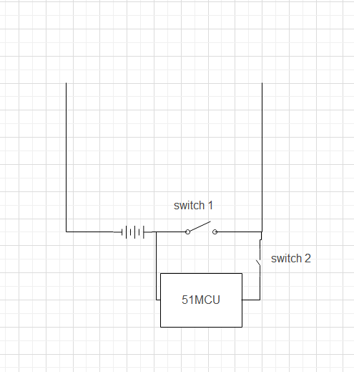image 3

The backup battery is connected with all LEDs and two switched are applied to control to system. One is by hand-controlled and the other is automatic.

The automatic switch:

The automatic controller model is designed with a 51MCU and a stepping motor. I programmed so that when the MCU’s input p01 is at 0 signal which means the center Tesla Tower is not working properly and then the output P02 will give a 1 signal to control the stepping motor moving and the switch 2 can be closed, powering for the LEDs.

The hand-controlled switch:

The hand-controller is designed for the emergency when the automatic controller is not working well. When the wireless power transfer system is failed and the automatic backup switch is not working, how could we make it possible to light the city? Here is the answer: a man goes to the backup system area and turn on the switch 1, the hand-controlled switch and the backup power source will give the whole city with the power to light up.

As a result, the backup system acts in this way. At first, when the emergency happens, the signal of input p01 becomes 0 and the output p02 will give a 1 signal to the stepping motor to close the switch 2. But if the automatic switch is out of control and the switch 2 is not closed, a man can close the switch 1 by hand so that the backup system will work. This can make sure the illumination system works all the time.

## The General Design

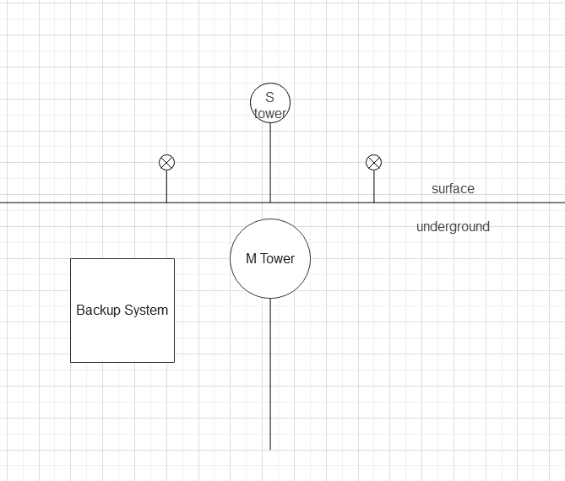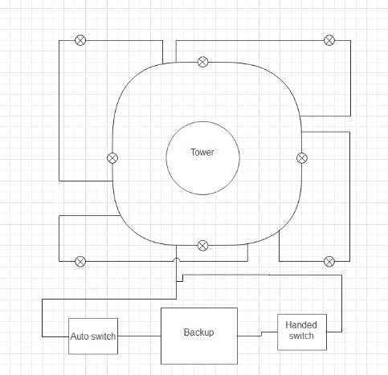image 4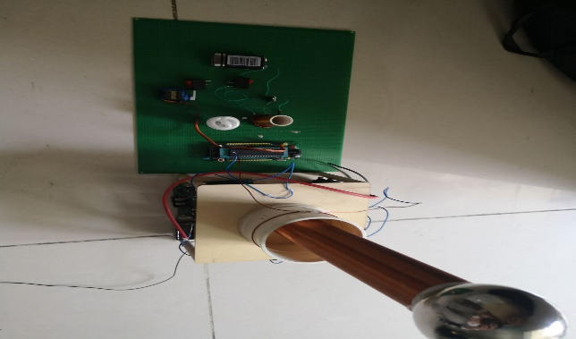image 5

As you can see from image 4&5, the M Tower is underground, generating high frequency alternating electric field. Then, the S tower which is on the surface accept the field as a medium, giving power to the illumination system.

# Result of the experiment

## Test of the wireless energy transmission

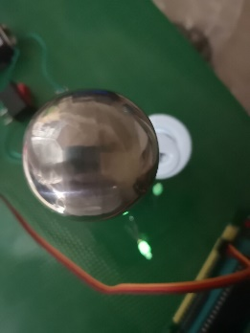image 6

The wireless energy transmission is successful. However, there are two problems. First, the power is not sufficient enough to light the bulbs totally. Second, the distance is limited which means the power can not be transferred in a long distance.

## Test of the backup system

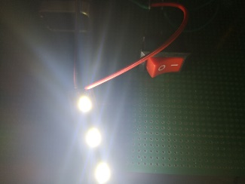image 7

The backup system worked well.

Nanjing University of Information Science & Technology.

## Test of the automatic backup function

As long as the 51MCU had detected the signal, the switch 2 closed and the backup system worked well.

# Further Applications & benefits

Despite the fact that the wireless power transfer system has some problems, which makes the system unpractical. There are still a lot of benefits once we make the system possible.

## Illumination in poor areas and mountain areas

Although the technology is well developped today and many human cities are illuminated by electricity, there are still a lot of poor areas where people there can’t afford for the electricity and mountain areas where the electricity can not be tranferred. The kids there don’t have a good condition to have classes and reading books at night. Eye deseases may happen to them. Besides, they don’t have a chance to watch TVs, to use the internet and most important, to know the world outside well, stucking themselves in a poor, small and knowledgeless box. However, if the wireless energy transfer system can work, since there’s no need for the wires, the illumination in these areas can be possible. They just need bulds and they can have light. All the electrical devices like TVs, cell phones, computers and redios, especially the medical devices, can work without wires. They don’t have to worried about the fee because the power is generated in a centred area and tranferred wirelessly for everyone to use anytime and anywhere.

People live in these areas must have a good improvement on their life standards.

## Green Resource vehicles

Since the power can be wirelessly transferred around the city, the electrical vehicles can be used without worrying about the power shortage. They can run all the time without charging. If possible, the air transports can also run in electricity and so are the ocean transports.

The air pollution caused by todays vehicles can be decreased. People will enjoy much more fresh air and have a better physical condition.

## The circle of Energy rescource

As we know, the electricity can be generated by a lot of ways like water, wind, solar and so on. A lot of clean ways to generated the electricity, and all of them are based on the sun light originally. So we can get rid of the dependence on the fossil resources which are not clean and efficient. We can independent from nuclear which may cause terrible results like leaking and radioactivity. What we are supposed to do is to fully make use of the solar energy, building total natural circle of energy resource which will run smoothly and peacefully and naturally.